1. **Justification for selecting a specific architecture pattern for Case study project**

For this explanation, we decided to use Web-based Architecture. From the explanation of Web-based Software Architecture, this is one of the suitable architectures that we can choose for web developing. Web-based Architecture has three tier layers, which Is the Web Server, Application Server, and Database, and in total of all, there are 4 type of web-based architecture showed by the picture below

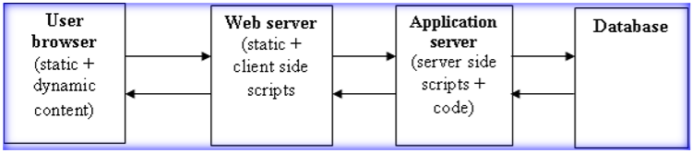

For the first, the user browser is for the interface of the client side of the user when use the website and getting the information and contains the data from the web server which is connected to the application server and database.

Web server is the client-side script or the front-end interface for sending the data to the user web browser and getting and sending all the information and contain the data from Application server.

Application server is the server-side scripts, in here we put all the code and script for our data and information to show the user and to send the information to web server.

The database is for storing the data and details for the application server and for the future use.

The reason we use web based architecture because in this architecture, we can maintain and update from few different teams, from the front-end, back-end, and database. For our team has front-end, back-end, and database analyst, this is a good chance to use all of our teams skills and effort for this website development.

**2. Logical and Physical diagrams of the chosen architecture pattern for Case study project**

**Logical and Physical Diagram**

We are using Web-based Architecture

**Logical Diagram**

For the first figure of our team’s Web-based Architecture

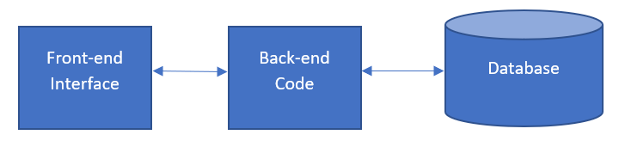

**Figure 1**

And for the Web-based Architecture second figure

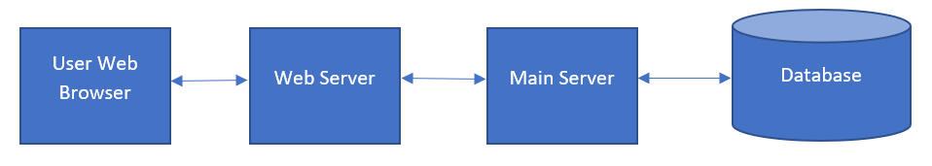

**Figure 2**

From the diagram we know that our outline will be only three section shows on figure 1 which is the Front-end Interface section, Back-end section, and Database Section. This outline will be described as shown as the Figure 2. Figure 2 explain about our layout of the website, in the picture it shows we have three section which is divided by the figure 1, User Web Browser, Web Server, Main Server, and Database. The User Web Browser Section will be the code for the front-end interface script for the user to see and use. Web Server is for connecting, getting, and sending the data and information from the Main Server (Server SIde) to the User Web Server (Client Side). The Main Server is our most of the work for this project and contain all of the back-end code for running this website, functions, and features based on database section. Then, last is Database section, in this section will stored all of the data and information from the client-side or even from the Server-side.

**Physical Diagram**

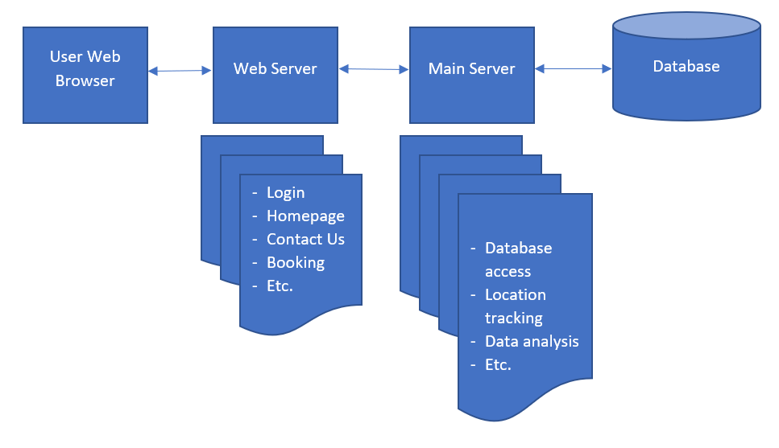

**3. Component Diagram for Case study project**



**4. Data Flow Diagram for Case study project**

